**Cravings and Urges**

Cravings/urges to use are a natural part of overcoming dependence. They are the result of long-term alcohol and drug use and can continue long after you stop using. Generally, people with a history of heavier use will experience stronger urges.

Cravings can be triggered by: people, places, things, feelings, situations or anything else that has been associated with drinking/using drugs in the past.

Cravings are most intense in the early parts of stopping/cutting down, but people may continue to experience cravings for the first few months and sometimes even years after ceasing use/drinking.

Cravings/urges are like waves at a beach:



Every wave/craving starts off small, and builds up to its highest point, and then it breaks and flows away.

Cravings will only lose their power if they are NOT strengthened (reinforced) by using drugs or drinking. Using occasionally will only serve to keep cravings alive. Cravings are like a stray cat - if you keep feeding them, they will keep coming back.

Each time you do something other than drink/use drugs in response to a craving, it will lose its power. The peak of the craving wave will become smaller, and the waves will be further apart. This is known as ‘extinction’.

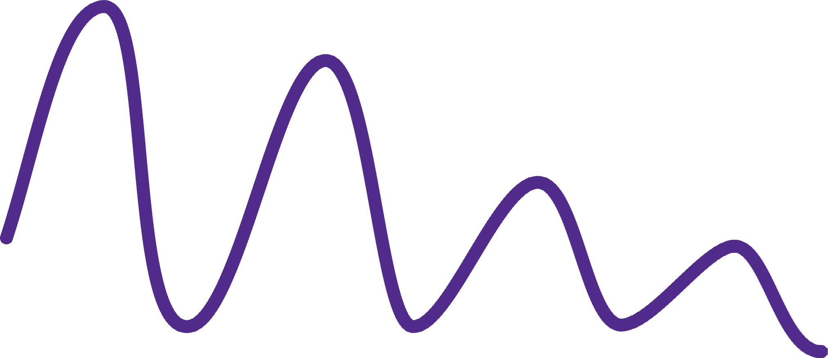

If you don't give in to the cravings, overtime they'll become less intense and less frequent, and abstinence from alcohol and drugs is the best way to ensure the most rapid and complete extinction of cravings. It is worth remembering that sometimes, particularly in response to stress and certain triggers, the peak can return to the maximum strength but will decline when the stress subsides.